Chapter2 Revision
Name: ____________________ Class: ____________________ Due date:
1. - (0620- S 2013- Paper 1 (Core)/1- Q4) - ATOMS AND ELEMENTS
$\frac{27}{13}x$Element X is represented by .
Which statement about element X is correct? （ ）
A An atom of X contains 13 protons and 13 neutrons.
B An atom of X contains 27 protons and 13 electrons.
C X forms an ion by gaining electrons.
D X is placed in Group III of the Periodic Table.

2 - (0620- S 2013- Paper 1 (Core)/2- Q5) - ATOMS AND ELEMENTS
The diagram shows an atom of an element.
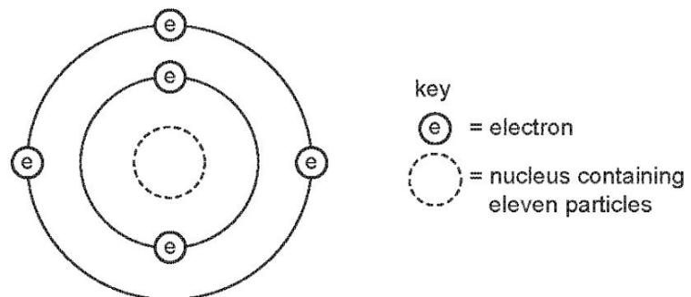
How many protons and neutrons are in the nucleus of the atom and in which group and period of the Periodic Table is the element found? （ ）
 | number of protons | number of neutrons | group number | period number
A | 5 | 6 | 3 | 2
B | 5 | 11 | 2 | 3
C | 6 | 5 | 3 | 2
D | 6 | 11 | 2 | 3

3 - (0620- W 2013- Paper 1 (Core)/1- Q4) - ATOMS AND ELEMENTS
Element X has 7 protons. Element Y has 8 more protons than X.
Which statement about element Y is correct? （ ）
A Y has more electron shells than X.
B Y has more electrons in its outer shell than X.
C Y is in a different group of the Periodic Table from X.
D Y is in the same period of the Periodic Table as X

4 - (0620- W 2013- Paper 1 (Core)/2- Q4) - ATOMS AND ELEMENTS
$​_{11}^{23}Na$Which statements about a sodium atom, , are correct? （ ）
1 The number of protons and neutrons is the same.
2 The number of protons and electrons is the same.
3 The number of outer electrons is one.
A 1, 2 and 3 B 1 and 2 only C 1 and 3 only D 2 and 3 only

5 - (0620- S 2015- Paper 1 (Core)/3- Q3) - ATOMS AND ELEMENTS
Two atoms, X and Y, can be represented as shown.
Which statement is not correct? （ ）
A X and Y are atoms of different elements.
B X and Y are isotopes.
C X and Y have different mass numbers.
D X and Y have the same number of electrons.

6 - (0620- W 2017- Paper 2 (Extended)/1- Q5) - ATOMS AND ELEMENTS
Which statement explains why isotopes of the same element have the same chemical properties? （ ）
A They have a different number of neutrons in the nucleus.
B They have the same number of neutrons in the nucleus.
C They have the same number of outer shell electrons.
D They have the same number of protons as neutrons.
7 - (0620- W 2017- Paper 2 (Extended)/3- Q5) - ATOMS AND ELEMENTS
$​^{12}C$$​^{13}C$$​^{14}C$Carbon has three naturally occurring isotopes, , and .
Which statement explains why the isotopes have the same chemical properties?（ ）
A They have the same number of electrons in the first shell.
B They have the same number of electrons in the outer shell.
C They have the same number of neutrons in the nucleus.
D They have the same number of protons as neutrons.

8 - (0620- W 2018- Paper 2 (Extended)/3- Q4) - ATOMS AND ELEMENTS
X and Y are both atoms.
X and Y have the same chemical properties as each other.
Which row describes the atomic structures of X and Y? （ ）
 | X |  |  | Y
 | protons | neutrons | electrons | protons | neutrons | electrons
A | 6 | 6 | 6 | 6 | 6 | 7
B | 6 | 6 | 6 | 6 | 8 | 6
C | 6 | 6 | 6 | 16 | 16 | 16
D | 7 | 6 | 7 | 6 | 6 | 7
9 - (0620- S 2014- Paper 4 (Extended)/1- Q1) - ATOMS AND ELEMENTS, ATOMS COMBINING
The table below gives the composition of six particles which are either atoms or ions.
particle | number of protons | number of neutrons | number of electrons
A | 33 | 40 | 33
B | 19 | 20 | 18
C | 34 | 45 | 36
D | 33 | 42 | 33
E | 13 | 14 | 13
F | 24 | 28 | 21
a.Which particles are atoms? Explain your choice.
b.Which particle is a negative ion and why has this particle got a negative charge?
- Which particles are positive ions?
d.Explain why particle A and particle D are isotopes.
9 - (0620- W 2016- Paper 4 (Extended)/2- Q2) - ATOMS AND ELEMENTS
This question is about atoms, ions and isotopes.
a.Define the term nucleon number.
.......................................................................................................................[2]
b.Give the electronic structure of the following atom and ion.
Na .......................................................................................................................
P3-.......................................................................................................................[2]
c.State one medical use of radioactive isotopes.
.......................................................................................................................[1]
d.What is meant by the term relative atomic mass?
.......................................................................................................................[2]
e.Suggest why the relative atomic mass of chlorine is not a whole number.
.......................................................................................................................
.......................................................................................................................[2]
f.Aluminium is a metal in Group III.
Describe the bonding in aluminium. Include a labelled diagram and any appropriate charges in your answer.
.......................................................................................................................
.......................................................................................................................
15-(0620-W 2017-Paper 4 (Extended)/1-Q1)-ATOMS AND ELEMENTS
The table gives information about five particles. The particles are all atoms or ions.
particle | number of protons | number of neutrons | number of electrons
A | 6 | 8 | 6
B | 12 | 12 | 12
C | 13 | 14 | 10
D | 8 | 8 | 10
E | 11 | 12 | 11
Answer the following questions using the information in the table. Each particle may be used once, more than once or not at all.
A Which particle A,B,C,D or E
i is an atom with atomic number 12,......................................
ii.is an atom with nucleon number 14,,......................................
iii.is an ion with a positive charge,,......................................
iv.has only one electron in its outer shell?,......................................
B. D is an ion of an element.
Identify the element and write the formula of D.,.........................................................

27 - (0620- S 2019- Paper 4 (Extended)/1- Q1) - ATOMs AND ELEMENTS
This question is about the structures of atoms and ions.
a.Define the term proton number. [2]
$\frac{24}{12}$$\frac{26}{12}$b.i.Complete the table to show the number of protons, neutrons and electrons present in atoms of Mg and Mg.
 | number of protons | number of neutrons | number of electrons
24Mg
26Mg
$\frac{24}{12}$$\frac{26}{12}$ii.What term is used to describe atoms of the same element, such as Mg and Mg?
$\frac{24}{12}$$\frac{26}{12}$iii.Explain why the chemical properties of Mg and Mg are the same.
[2]
c.Complete the table to identify the atoms and ions which have the following numbers of protons, neutrons and electrons.
 | number of protons | number of neutrons | number of electrons
23Na+ | 11 | 12 | 10
 | 4 | 5 | 4
 | 17 | 20 | 18
d.State the electronic structure of the following atom and ion.
Al ......................................................................................................................
S2-......................................................................................................................

32 - (0620- W 2019- Paper 4 (Extended)/1- Q2) - ATOMs AND ELEMENTS, REACTING MASSES AND CHEMICAL EQUATIONS, SOME NON- METALS AND THEIR COMPOUNDS
a.Sulfur exists as a number of different isotopes.
What is meant by the term isotopes?
......................................................................................................................
b.A sulfide ion has the symbol shown.
How many neutrons are contained in this sulfide ion
......................................................................................................................?
$S^{2−}$ii.How is a sulfide ion, , formed from a sulfur atom?
......................................................................................................................
$S^{2−}$iii.Which element forms an ion with a2+ charge that has the same number of electrons as a ion?
......................................................................................................................[1]

38-(0620-W 2020-Paper 4 (Extended)/3-Q2)-ATOMS AND ELEMENTS
The table gives information about five particles, A, B, C, D and E.
particle | number of electrons | number of neutrons | number of protons
A | 10 | 13 | 11
B | 18 | 20 | 18
C | 18 | 18 | 18
D | 10 | 12 | 8
E | 10 | 10 | 10
a.State the atomic number of A.
b.State the nucleon number of B.
c.Write the electronic structure of C.
d.Give the letters of all the particles which are:
e.atoms [1] (ii) positive ions [1] (iii) negative ions [1] (iv) isotopes of each other. [1]

10. The table gives some information about four different particles, A, B, C and D.
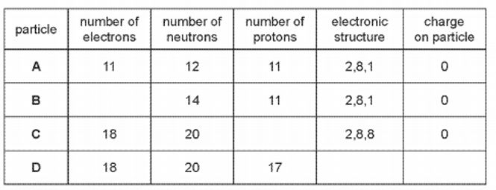

(a) Complete the table. The first row has been done for you.
(b) Give two particles from the table which are isotopes of each other.

(c) Element Z is in the same group of the Periodic Table as A and has 2 electric shells.
State the identity of element Z.

(d) C is unreactive.
Use information from the table to explain why.

4. The table below gives the composition of six particles which are atoms or ions.
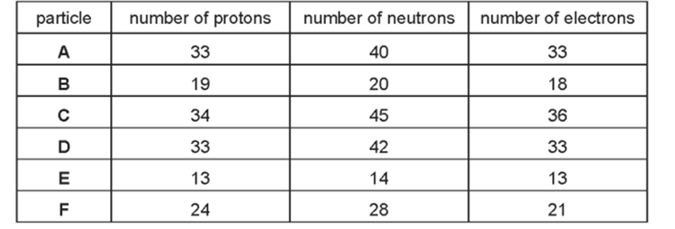
(a). Which particles are atoms? Explain your choice.

(b).Which particle is a negative ion and why has this particle got a negative charge?

(c).Which particles are positive ions?
(d).Explain why particle A and particle D are isotopes.

6. 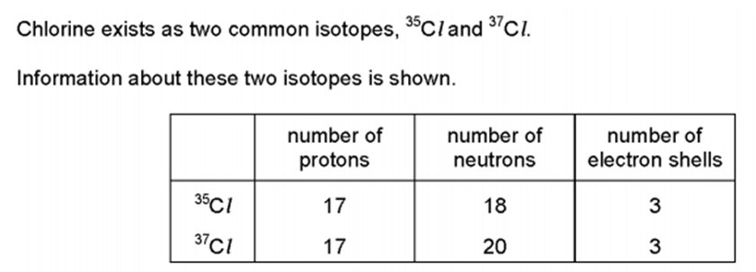
Which statement explains why the two isotopes are of the same element?（ ）
A. Both have the same number of electron shells.
B. Both have the same number of protons.
C. Both have 7 outer shell electrons.
D. 37Cl has 2 more neutrons than 35Cl.

9 - (0620- S 2020- Paper 2 (Extended)/1- Q4) - ATOMS AND ELEMENTS
The atomic number and nucleon number of a potassium atom are shown.
 | potassium atom
atomic number | 19
nucleon number | 39
$K^{+}?$How many protons, neutrons and electrons are in a potassium ion.
 | protons | neutrons | electrons
A | 19 | 20 | 18
B | 19 | 20 | 20
C | 20 | 19 | 18
D | 20 | 19 | 19

